Archery simulator

Overview
My game will be an archery simulation where the player is at an archery range with different bows in front of them (eg. Longbow, compound bow, recurve bow) ant targets at various distances , the bows will shoot differently as they do in real life and if you want more of a challenge you can press a big red button beside you and the targets move, faster or slower depending on what you want, to finish the game you need to hit all of the targets, not well but hit them.

Hardware Requirements
The vive will be used

Gameplay / Experience

Events/Phases
The events of the game are that you are at an archery range with different bows in front of you and the way to win is to hit all the stationary targets, you don’t have to score well just hit them as It may be hard to do

Mechanics
Some things the player can do in this game are
Get a sense of what real life archery looks like
They can test out different bows that shoot differently like a compound bow is going to shoot differently to a long bow, an example of this is at longer ranges, with a compound bow being stronger you can aim closer to the target because the arrow doesn’t need to arc as much to reach that distance, conversely a longbow regularly needs to be aimed up to a 45 degree angle to reach the same distances(but that half the fun of it).
The player can test out different fictional and historical arrows like a fire arrow or a whistling arrow or if you want you could see what the English shot at Agincourt (heavy bodkin arrows designed to penetrate heavy armour)
The player can also make it harder by pressing a button that makes the targets move, this will reveal more buttons, to speed p and slow down the now moving targets.
If you want you can explore down range and see where your arrow landed to improve your aim

Tutorial Elements
The tutorial element will consist of a “tutorial bow” this will act as an aim assist, showing the player different arrow trajectories based on what bow you use, as well as that if you turn it on there will be a shot camera that gives you a better visualisation of where your arrow went

Visuals

Style
I’m thinking of going for a stylised theme with bright colours, a bit like the image below
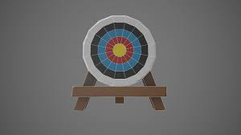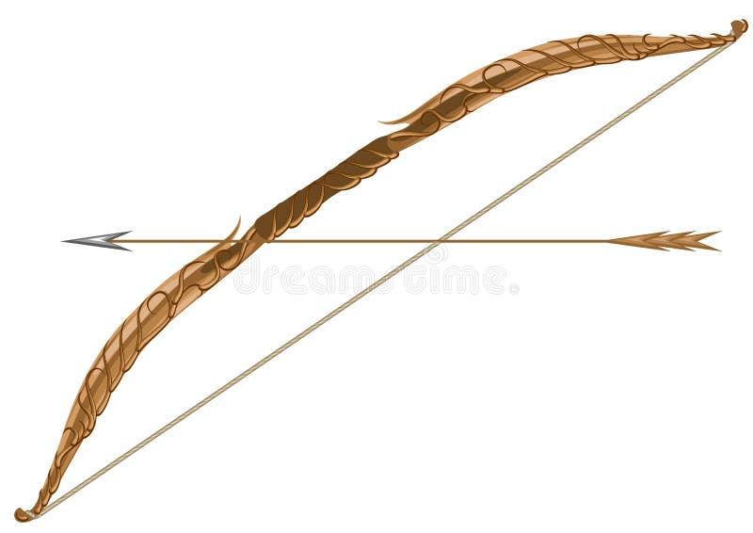

Sources

The main source of this will be what I can make myself or what I can find on the unity asset store as I do have the bows needed for the game but they are not here in stoke so I cannot 3d scan them into the game , shame, some of my longbows are a work of art. The unity asset store does have some bows but not all that I want in the game so I will make the ones I cant find elsewhere , for these I will use blender

Effects
Some effects I will need are both visual and auditory, I will need an arrow vfx when it leaves the bo, normally in reality there is to vfx accompanied with an arrow flying as it is traveling too slowly but for the game I will add a vfx to the arrow, I will also need some sounds of different bows being shot which I can get from back home, I will also want to add a hit sound to tell the player they have hit the target.

UI Elements
Some UI elements I will have is on the shaft of the bow will be a visualization of the power of the bow being used and how much power you are using this will be conveyed through a slider changing colour the more power you use

Sounds
The sounds needed for this game to be the best it can be include sounds of arrows being shot from bows and the sound of arrows hitting targets

